 

**Placement Empowerment Program**

***Cloud Computing and DevOps Centre***

**Set Up a Cloud-Based Monitoring Service:**Enable basic cloud monitoring (e.g., CloudWatch on AWS). View metrics like CPU usage and disk I/O for your cloud VM.

Name: Mathimalar.P Department : ADS



**Introduction and Overview**

Cloud-based monitoring services like Amazon CloudWatch enable the tracking and analysis of metrics related to cloud virtual machines (VMs). By setting up monitoring, you can gain insights into the performance and health of your cloud resources, such as CPU usage, disk I/O, and network traffic. This allows you to take proactive actions to ensure optimal performance and resource allocation.

**Objective**

• Set up **basic cloud monitoring** for your cloud VM using services like **CloudWatch on AWS**.

• Monitor key performance metrics such as **CPU usage**, **disk I/O**, and **network traffic**.

• Ensure continuous performance analysis and early detection of potential issues..

**Importance**

**• Performance Optimization –** Helps in monitoring and optimizing cloud resource utilization.

**• Proactive Issue Detection –** Identifies performance bottlenecks or failures early, minimizing downtime.

**• Cost Efficiency –** Enables better resource allocation based on usage trends, preventing over-provisioning.

**• Real-time Insights** – Provides real-time visibility into VM metrics, helping in quick decision-making.

**Step-by-Step Overview**

1. Enable Monitoring for Your Virtual Machine:

* Log in to your AWS management console.
* Navigate to EC2 section.
* Select the instance you want to monitor.
* Go to the "Monitoring" tab of the instance and enable detailed monitoring (if not already enable.
* Save the changes to ensure monitoring is activated.

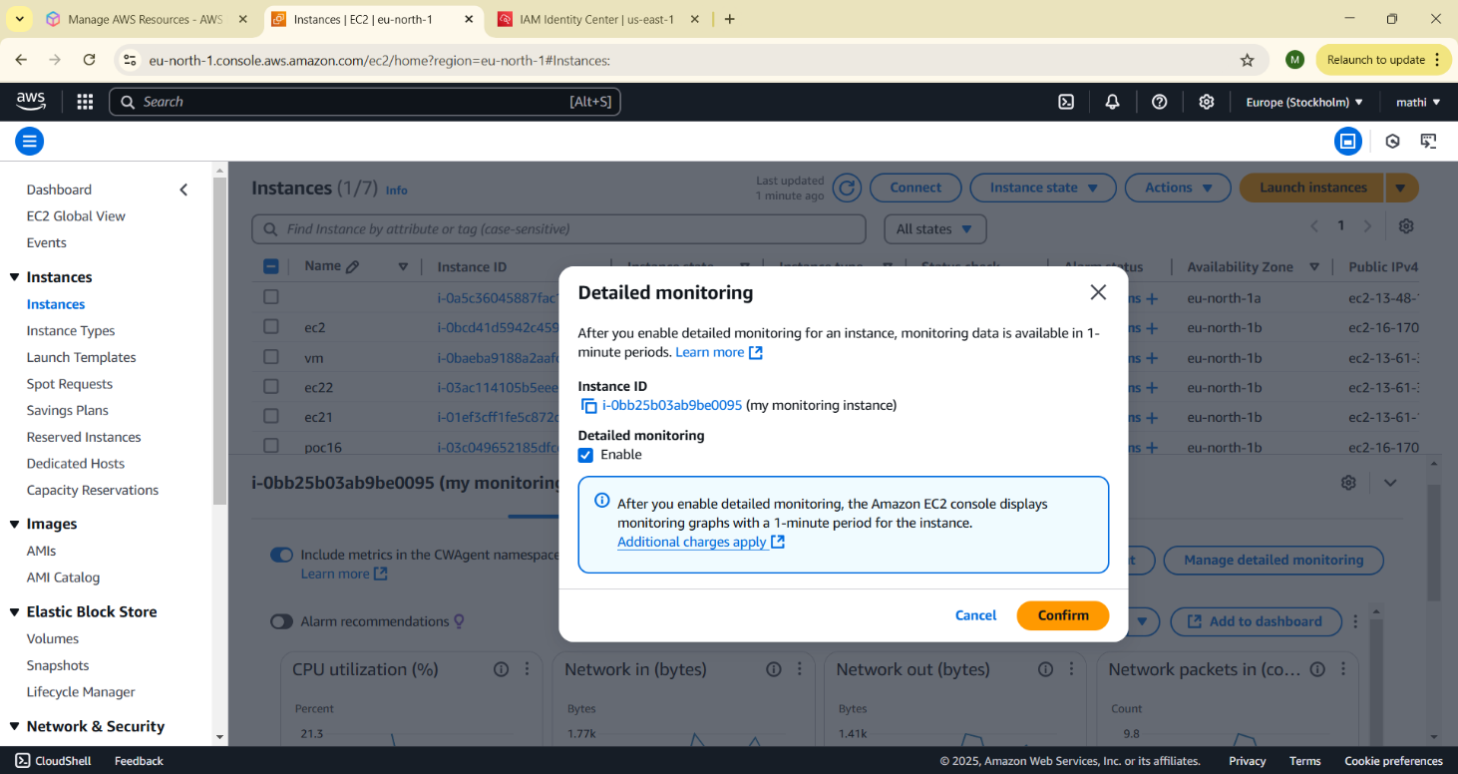

**2. View Metrics in the Monitoring Dashboard**

Open the monitoring dashboard in the aws console.

* Navigate to the Amazon CloudWatch dashboard.
* Select the instance you wish to monitor.
* View real-time and historical metrics such as: CPU Utilization, Disk I/O, Network Traffic.
* Use the graphical interface to customize charts or add widgets for frequently monitored metrics.

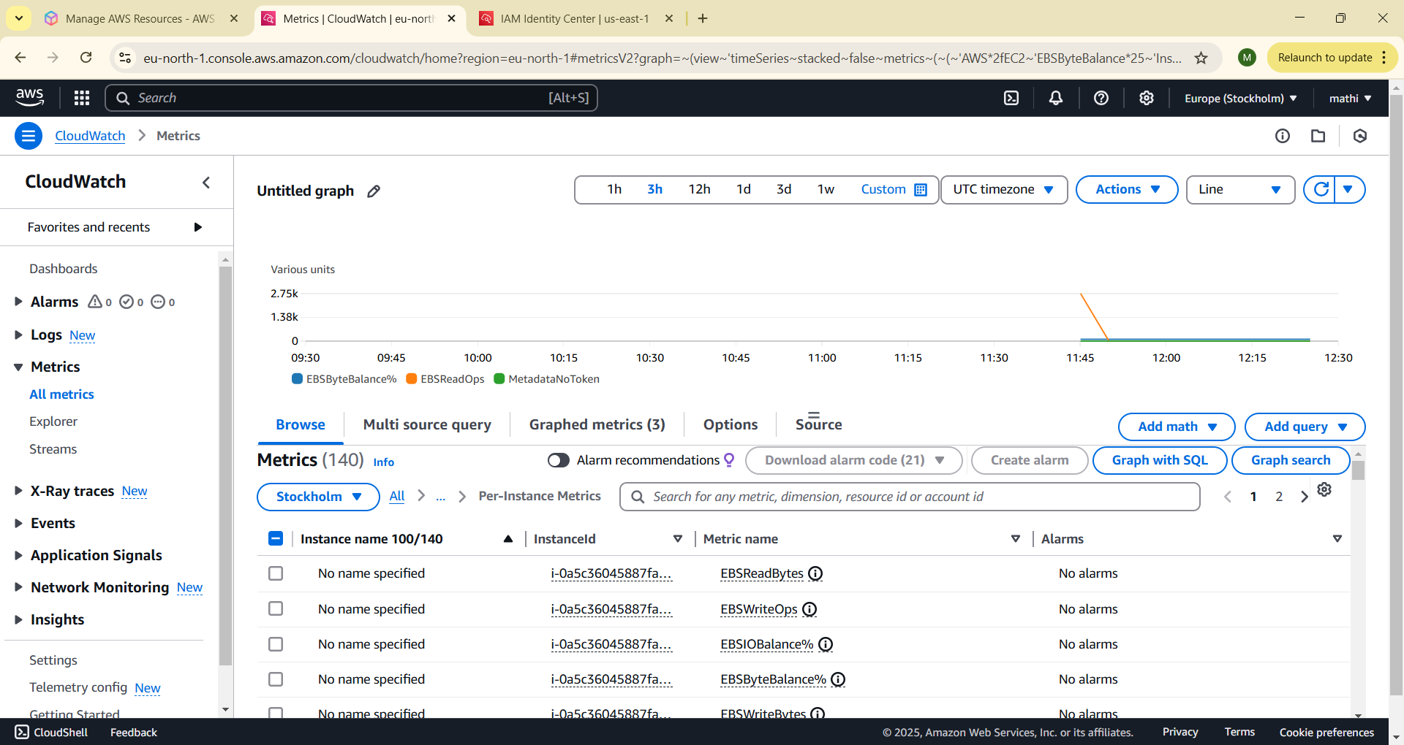

**3. Set Up Alarms**

* In the monitoring dashboard, locate the "Alarms" or "Alerts" section.
* Create a new alarm. Define the metric to monitor (e.g., CPU utilization above 80%). Set the threshold value and duration to trigger the alarm.
* create an SNS (Simple Notification Service) topic and subscribe to it.
* Save and activate the alarm.

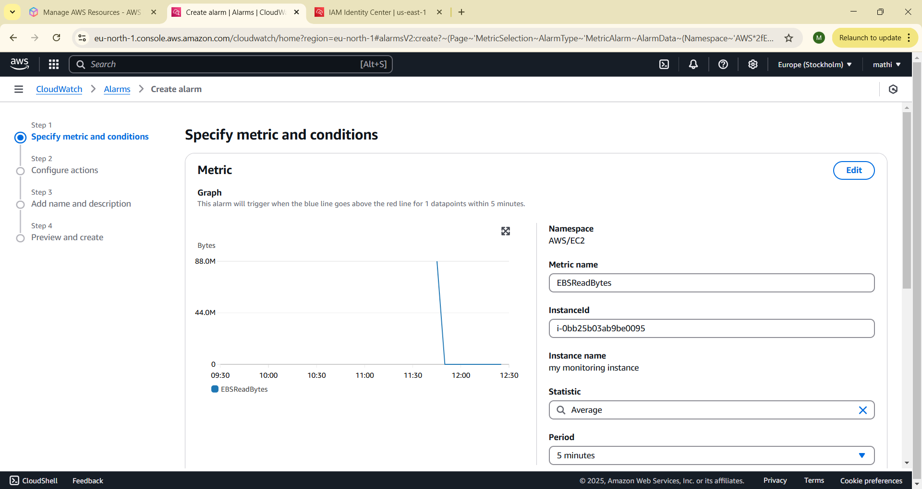

**4. Analyze Performance Trends**

* Review collected metrics over time to identify trends or anomalies.
* Export logs or reports for deeper analysis

**Expected Outcome**

* **Increased Visibility** – Detailed monitoring of cloud VM performance through metrics.
* **Timely Alerts** – Ability to set thresholds for critical metrics, receiving alerts for abnormal conditions.
* **Improved Performance** – Continuous monitoring helps ensure the VM is running at optimal efficiency.
* **Scalable Monitoring** – Easily scale monitoring for multiple instances and resources as needed.

By implementing this monitoring setup, you ensure that your cloud resources are running efficiently and can quickly address any issues that arise.